Nevada State Firefighters’ Association
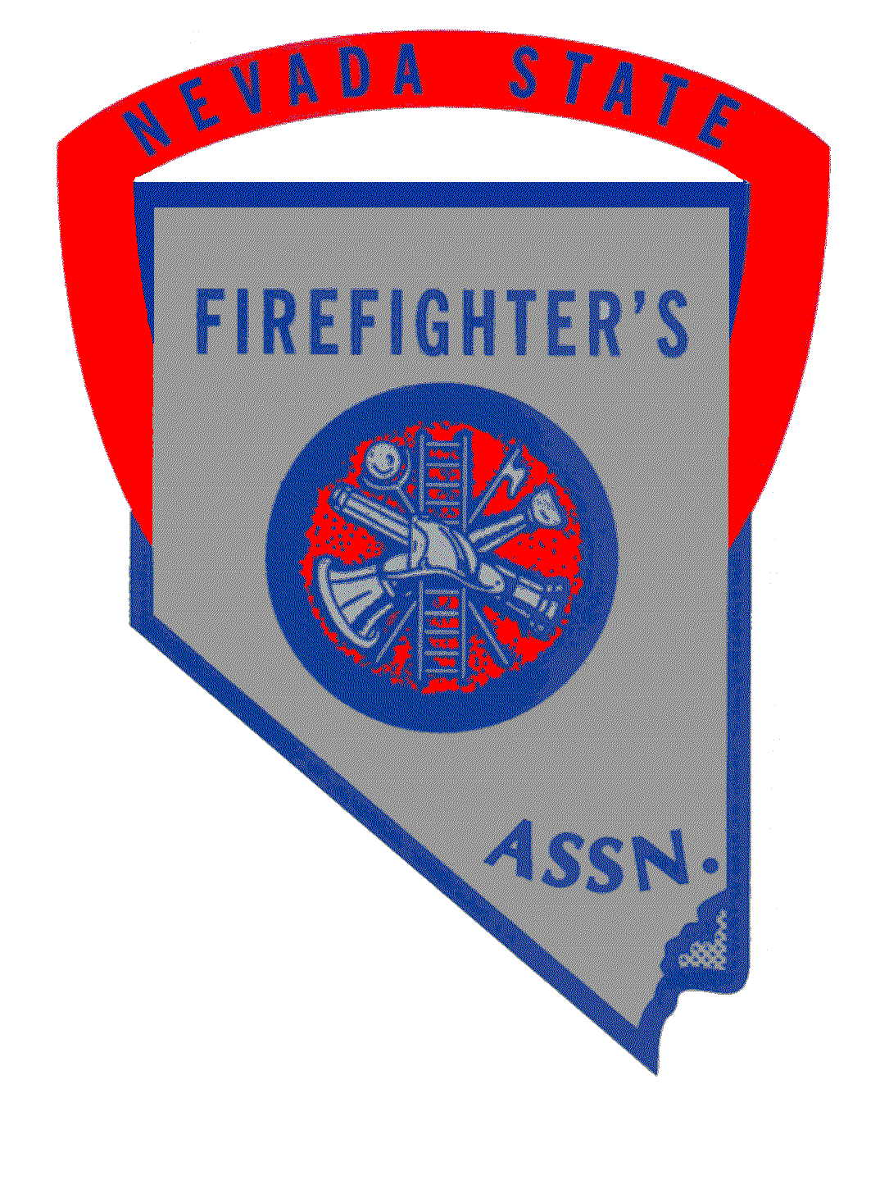

P.O. Box 907
Lovelock, Nevada 89419
Business: 775-223-3182 Website: www.nsfa.org

5/28/2025

Dear members, associate members, vendors and supporters,

It is with sincere regret that we inform you of the cancellation of this year’s Annual training Conference. The host city, Fallon/Churchill Volunteer Fire Department , has made the difficult decision to cancel due to insufficient registration numbers.

While the news is disappointing to all of us who look forward to the camaraderie, training, and networking the conference brings, the NSFA fully supports the host city’s decision and understands the challenges they faced. We extend our gratitude to Fallon/Churchill VFD for their efforts and dedication, and we hope they will consider hosting again in the future.

Refunds for the conference registration will be issued by the host city within a reasonable time frame. We appreciate your patience as they work through that process.

The NSFA will still hold its annual membership meeting as scheduled on Saturday June 28, 2025. We will provide additional information and the Zoom link soon.

Thank you for your continued support and commitment to Nevada’s fire service community.

Jamie Winrod
President, Nevada State Firefighters Association

Jamie Winrod

President

Ralph Hamman

Vice President

Larry Haydu
Director

Jacob Stark
Director

Ken Smith
director

Mark Flesher
Past President

.

mike Heidemann
Executive
Director

